Algorand Opt-In Guide for BUY Token

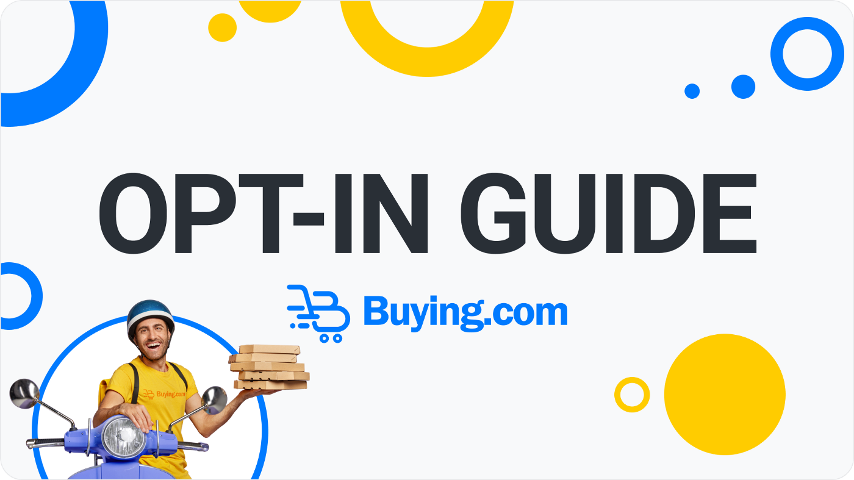

Are you ready to invest in $BUY token? Here is a helpful guide to ensure that your Algorand wallet can receive your tokens after purchase.
The Rundown
The Buying.com token is called $BUY and it resides on the Algorand blockchain. The Algorand requires a mandatory opt-in process in order to receive your new tokens, so, there’s a few simple but necessary steps that you’ll need to take to prepare your wallet to accept your $BUY.
Let’s get started!
Here’s what you’ll need:
- An Algorand Wallet. We recommend MyAlgoWallet.
Steps:
1. Click “Access Now”
2. Review the T&C
3. Create your password
4. Click “New Wallet”
5. VERY IMPORTANT: Review and store your Mnemonic Phrase in a safe place and never share it. We recommend writing physical copies of this phrase and storing them in multiple places.
6. Verify Phrase
7. Give a name to your wallet
8. Click “Create Wallet”
9. Enter your password
And… You’re done!
- A small balance of Algo tokens
The Algorand gas token is called ALGO. You’ll need to have a minimal amount of ALGO in your wallet in order to pay for the opt-in fees and token reservation. You can find the ALGO trading pairs on the CoinGecko Markets page.
The Opt-In gas fee will be low (approximately 0.001 ALGO) but you also need a minimum amount of ALGO’s in your wallet to keep it active. Which is 0.1 ALGO per token, including for the ALGO token itself. If you only have ALGO tokens in your wallet and want to receive $BUY we suggest a minimum balance of 0.3 ALGO.
The Opt-In Process
This is a mandatory and manual action you need to take in order for your wallet to receive and interact with the $BUY tokens. It is done via “Algorand MyAlgo Connect.”
What is MyAlgo Connect? It’s a service that allows you to review and sign Algorand transactions, while enabling Algorand applications and tokens to connect with your MyAlgo Wallet and interact with the Algorand Blockchain safely and securely.
Follow these 3 easy steps to prepare your wallet to receive $BUY tokens (the opt-in).
*Reminder: You need a MyAlgo Wallet account AND a balance in ALGO tokens. (review above)
Opt-In Guide
STEP 1: Connect to your MyAlgo Wallet. Enter your password and mnemonic phrase.
STEP 2. Select the wallet you’d like to opt-in to receive $BUY tokens.
STEP 3: Click the drop down at the top that says “Balance” and then click “Add Asset.”
STEP 4: In the search bar type BUY and select “BUY Token ASA 137020565”
STEP 5. Click Asset Opt-In and enter your password.
And you’re done!
Verification: Your transactions list will read “completed” when the opt-in is complete.
*If you have any issues, please check if you have a sufficient ALGO balance in your wallet or if you have a popup blocker active.

